**GraphQL Client Call in with SpringBoot 3-2025**

There is a publicly hosted GraphQL api exposed for testing. We can use that one to make call.

Public URL: <https://countries.trevorblades.com/graphql>

To get Country Details by passing Country Code

Actual GraphQL Query is given below.

**query** Country {

    country(code: "IN") {

        code

        capital

    }

}

The screenshot is given below.

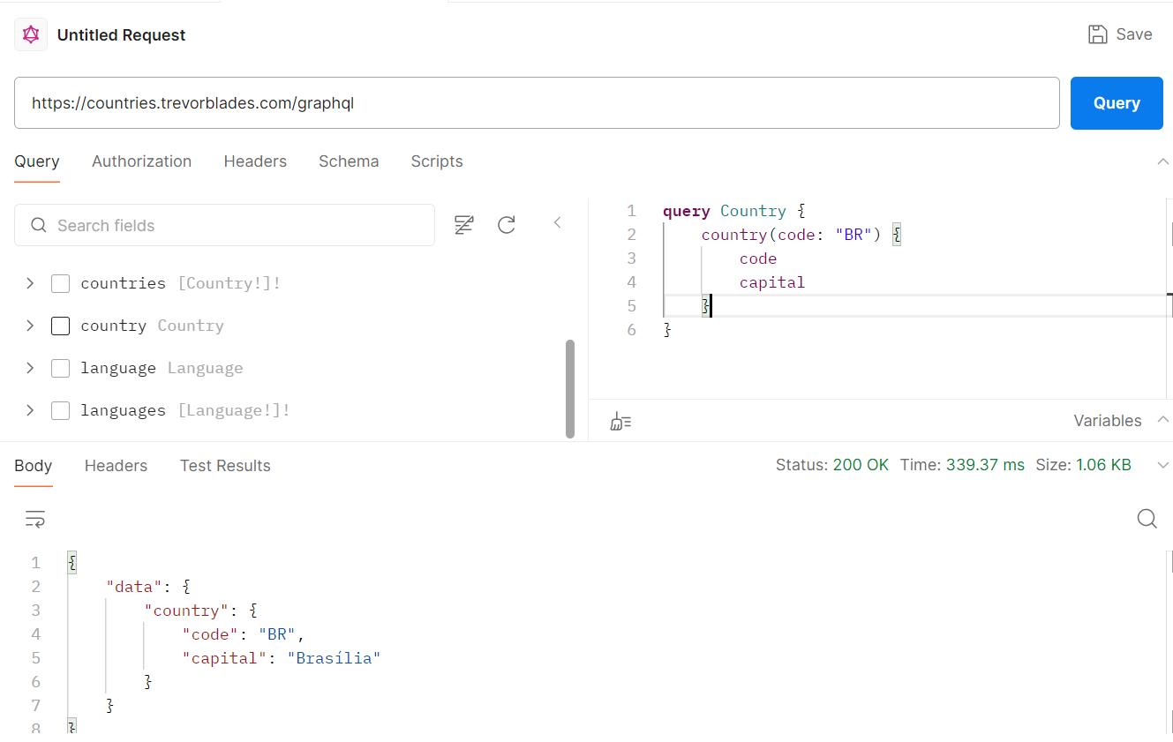

**Can the GraphQL query be called like normal HTTP ways ? Yes**

**How to Respond to GraphQL requests using an HTTP server**

**query** Country {

    country(code: "IN") {

        code

        capital

    }

}

The above graphql query can be written as below.

{

  "query": "query Country { country(code: \"BR\") { code capital }}"

}

In order to make HTTP Post call, you have to make HTTP Post call with the above query and in case of Postman client, paste the above query as **raw**. The screenshot is given below.

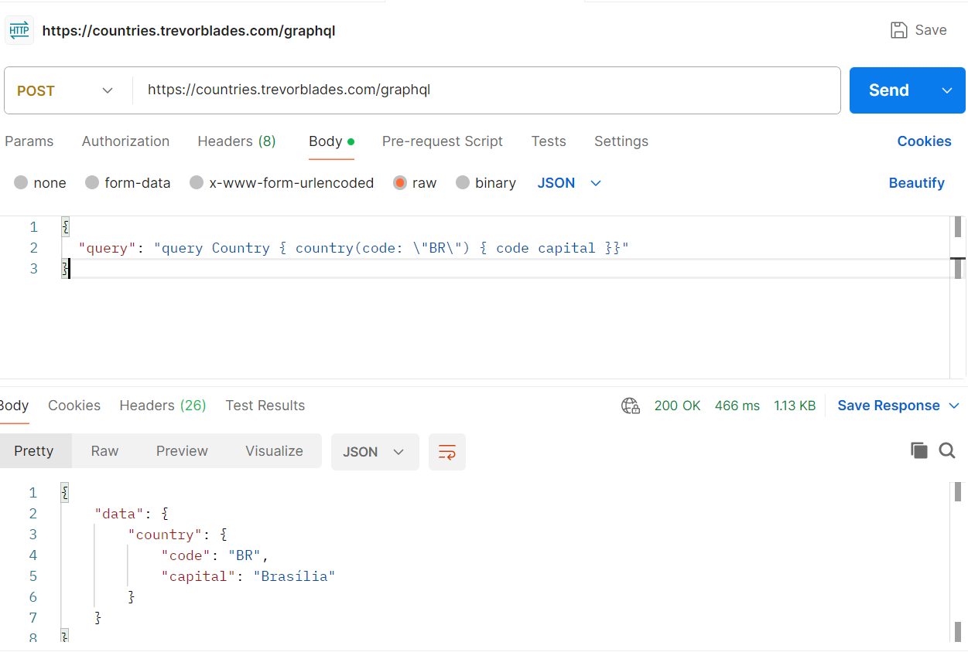

In case of dynamic values, the graphql query is given below.

**query($code: ID!) {**

**country(code: $code) {**

**code**

**capital**

**}**

**}**

The above query can be written as below.

{

  "query": "query($code: ID!) { country(code: $code) { code capital } }",

  "variables": {

    "code": "IN"

  }

}

Based upon the above query, you can make HTTP call in PostMan client. The screenshot is given below.

There is an online tool which can convert Graphql query to Json body.

<https://datafetcher.com/graphql-json-body-converter>

We can make GraphQL query call in various ways. Prominently, we can use **GraphQLWebClient** and **RestTemplate** as of now.

**How to use GraphQLWebClient**

First you can configure the URL for Graphql in application.properties as shown below.

**graphql.client.url**=https://countries.trevorblades.com/graphql

Actual graphql query is given below.

**query Country {**

**country(code: "BR") {**

**code**

**capital**

**}**

**}**

You need to Autowire as shown below.

@Autowired

**private** GraphQLWebClient graphQLWebClient;

The code is given below.

**public** **void** callUsingGraphQLWebClient() {

String queryStr1 = """

query($code: ID!) {

country(code: $code) {

code

capital

}

}

""";

Map<String, Object> variables = **new** HashMap<>();

variables.put("code", "IN");

GraphQLRequest request = GraphQLRequest.*builder*()

.query(queryStr1)

.variables(variables)

.build();

//print requestBody

System.***out***.println(request.toString());

//passing requestBody to server

GraphQLResponse response = graphQLWebClient.post(request).block();

System.***out***.println("Raw Response: "+response.getRawResponse());

}

Mark the difference

query($code: ID!) {

country(code: $code) {

code

capital

}

}

**query Country {**

**country(code: "BR") {**

**code**

**capital**

**}**

**}**

For another Graphql query, it is given below.

**query Countries {**

**countries(filter: { currency: { eq: "USD" } }) {**

**currencies**

**name**

**}**

**}**

For **GraphQLWebClient**, the above can be written as

String queryStr2 = """

query($eq11: String!) {

countries(filter: { currency: { eq: $eq11 } }) {

currencies

name

}

}

""";

The following variables will be used.

Map<String, Object> variables = new HashMap<>();

variables.put("eq11", "USD");

Let us check with a complex query with two dynamic variables.

Actual GraphQL query is given below.

**query** Countries {

    countries(filter: { code: { eq: "VA" }, continent: { eq: "EU" } }) {

        capital

        code

        awsRegion

        languages {

            name

            native

        }

    }

}

The above can be written for Java code as

String queryStr2 =

"""

query($eq1: String!, $eq2: String!) {

countries(filter: { code: { eq: $eq1 }, continent: { eq: $eq2 } }) {

capital

code

awsRegion

languages {

name

native

}

}

}

""";

All the java code for the above is same.

**The trick is given below.**

If the GraphQL query is given like this

**query** Countries {

    countries(filter: { code: { eq: "VA" }, continent: { eq: "EU" } }) {

        capital

        code

        awsRegion

        languages {

            name

            native

        }

    }

}

While writing query for java code execution,

First write as below. There is no need to mention the name of the query in the first line

**query($variableName1: DataType!, $variableName2: DataType!)** {

copy paste the graphql query with the **$variableName**

}

Like query($eq1: String!, $eq2: String!) { }

countries(filter: { code: { eq: $eq1 }, continent: { eq: $eq2 } }) {

capital

code

awsRegion

languages {

name

native

}

}

Final query should look like this.

String queryStr2 =

"""

query($eq1: String!, $eq2: String!) {

countries(filter: { code: { eq: $eq1 }, continent: { eq: $eq2 } }) {

capital

code

awsRegion

languages {

name

native

}

}

}

""";

In case of Mutation call, the complete code is given below.

**public** **void** mutationCall1() {

String queryStr2 =

"""

mutation($fName: String!, $lName: String!, $sta1: MaritalStatus, $sta2: Boolean) {

createAppUser(

inUser: { firstName: $fName, lastName: $lName, mStatus: $sta1, status: $sta2 }

) {

id

firstName

lastName

mStatus

status

salary

phoneNos

}

}

""";

Map<String, Object> variables = **new** HashMap<>();

variables.put("fName", "Hati");

variables.put("lName", "Ghoda");

variables.put("sta1", "MARRIED");

variables.put("sta2", Boolean.***TRUE***);

//setting up requestBody with query and variables

GraphQLRequest request = GraphQLRequest.*builder*()

.query(queryStr2).variables(variables).build();

//print requestBody

System.***out***.println(request.toString());

//passing requestBody to server

GraphQLResponse response = graphQLWebClient.post(request).block();

System.***out***.println(response.getRawResponse());

}

The actual GraphQL query is given below.

**mutation** CreateAppUser {

    createAppUser(

        inUser: {

            firstName: "Hati"

            lastName: "Ghoda"

            mStatus: MARRIED

            status: **true**

        }

    ) {

        id

        firstName

        lastName

        mStatus

        status

        salary

        phoneNos

    }

}

**How to use RestTemplate in GraphQL Call**

Complete Java code is given below.

**public** **void** usingRestTemplatecall1() {

String url = "https://countries.trevorblades.com/graphql";

String queryStr2 = """

query($eq11: String!) {

countries(filter: { currency: { eq: $eq11 } }) {

currencies

name

}

}

""";

RestTemplate restTemplate = **new** RestTemplate();

HttpHeaders headers = **new** HttpHeaders();

headers.setContentType(MediaType.***APPLICATION_JSON***);

//create requestBody with query

Map<String, Object> requestBody = **new** HashMap<>();

requestBody.put("query", queryStr2);

//create variables

Map<String, Object> variables = **new** HashMap<>();

variables.put("eq11", "USD");

//add variables in the requestBody

requestBody.put("variables",variables);

HttpEntity<Object> entity = **new** HttpEntity<>(requestBody, headers);

ResponseEntity<String> response = restTemplate.postForEntity(url, entity, String.**class**);

System.***out***.println(response.getBody());

}

For the above, GraphQL query is given below.

**query** Countries {

    countries(filter: { currency: { eq: "USD" } }) {

        currencies

        name

    }

}

**How to Use WebClient to make GraphQL Call**

Actual GraphQL Query is given below.

**query** Country {

    country(code: "IN") {

        code

        capital

    }

}

The above graphql query can be written as below for making HTTP call.

{

  "query": "query Country { country(code: \"IN\") { code capital }}"

}

Finally, the above code is written as below for Java

String body = """

{

"query": "query($code: ID!) { country(code: $code) { code capital } }",

"variables": {

"code": "IN"

}

}

""";

Java code is given below.

**public** **void** callUsingWebClient() {

String body = """

{

"query": "query($code: ID!) { country(code: $code) { code capital } }",

"variables": {

"code": "IN"

}

}

""";

WebClient webClient = WebClient.*create*(firstUrl);

String sss = webClient

.post()

.uri(firstUrl)

.contentType(MediaType.***APPLICATION_JSON***)

.bodyValue(body)

.retrieve()

.bodyToMono(String.**class**)

.block();

System.***out***.println(sss);

}

Check below for Analysis

Actual GraphQL query is given below.

**query** Country {

    country(code: "IN") {

        currency

        name

    }

}

Request Body for Http POST call for the above query is given below.

{

  "query": "query($code11: ID!) { country(code: $code11) { currency name } }",

  "variables": {

    "code11": "IN"

  }

}

References

<https://graphql.org/learn/serving-over-http/#post-request>

<https://datafetcher.com/graphql-json-body-converter>